Machete Operations and Maintenance

V1.0

Operations Tasks 2

Daily operations tasks 3

1. Review Machete Work Order Summary 3

Manager questions 4

1.1 Were all work orders assigned a worker and completed? Or alternatively, was the work order cancelled? 4

1.2 Are there any work orders in the past that are still active or pending? 4

2. Review Machete Work Orders 5

3. Review Work Orders by Color 5

Management Questions 6

3.1 Can the worker for the orange work order be found? If so, update Machete 6

3.2 Is the blue or grey order in the past? Do we have a paper record? Can we update Machete? 6

Weekly operations tasks 6

4. Review Monthly Work Order Statuses (pie charts) 7

Management Questions 7

4.1 Are the percentages of incomplete work orders shrinking? 7

4.2 Are there work orders in the past that are not completed or cancelled? 8

5. Review Incomplete Work Orders (List) 8

Manager Questions 9

5.1 Can we find which worker was assigned for a given incomplete work order? 9

5.2 Are the total numbers of incomplete work orders shrinking over time? 9

5.3 What can be done so that there are no incomplete orders in the coming month? 9

# Operations Tasks

Machete records work orders, assigns workers to those work orders, and captures the infomration into a database. Once the information is in the database, the task of analyzing it is much easier than when the information is record on paper slips. However, the review of operations is still an on-going maintenance task.

In order for Machete reports to be reliable, every effort should be made to keep Machete data current. The following list is a work in progress, but reflects the known tasks that must happen for Machete work order data to be reliable.

# Daily operations tasks

## Review Machete Work Order Summary

**(**[**http://machete/workorder**](http://machete/workorder) **-> Summary Tab)**

The Work Orders Summary page shows the volume and status of recent orders. There are 5 groups of columns that show order status. Each group has 2 columns: Work Order Count and Assignment Count. (highlighted color boxes are for illustration only).

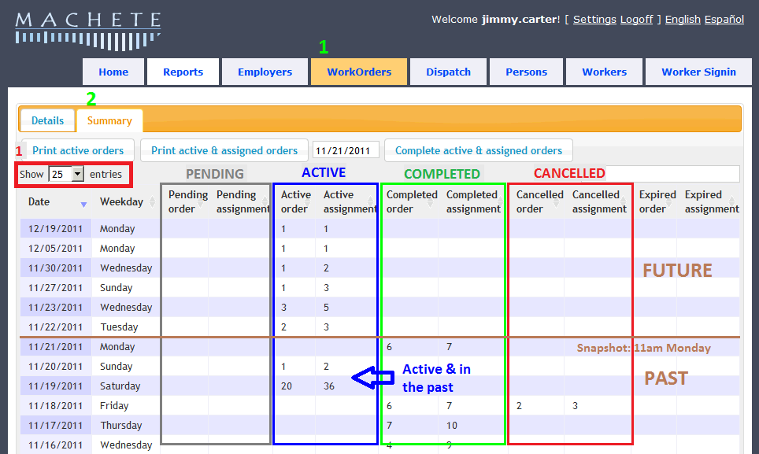

* Click on the WorkOrders Menu link (**Green #1**), then Click on the Summary Tab (**Green #2**)
* Notice the 5 groups: Pending, Active, Completed, Cancelled, and Expired. These are the possible status settings for a work order. The status reflects where the work order is in the dispatch process.
* The Order Count is different from the Assignment Count because an Order may need more than one worker. An assignment reflects the number of workers needed.
* As the current date progresses, Work Order counts should shift from Active to Completed or Cancelled. Assignments will shift with the work orders.
* The display can show up to 100 entries (**Red #1, above**). This allows for easy review of the past 3 months.

The Work Order Summary information is also available from a report 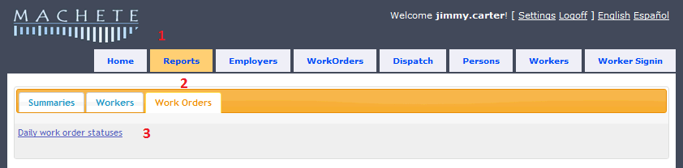

This link (**Red #3**) takes the user to the Microsoft SQL Server Reporting Server (SSRS). The SSRS is a separate, standard service of Microsoft SQL Server and provides a standard means for analyzing SQL Server data.

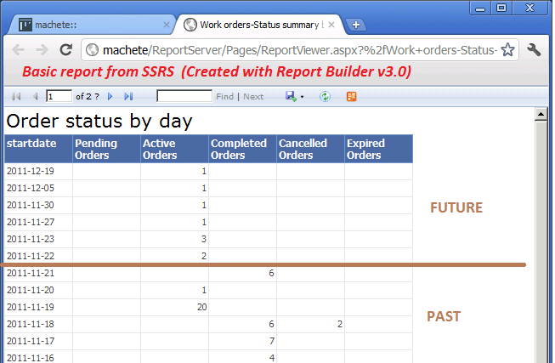

### Manager questions

#### Were all work orders assigned a worker and completed? Or alternatively, was the work order cancelled?

#### Are there any work orders in the past that are still active or pending?

The best time to complete work orders is on the same day that they were assigned and dispatched. If they cannot be completed the same day, they should be completed as soon as possible.

## Review Machete Work Orders

**(**[**http://machete/workorder**](http://machete/workorder) **-> Details Tab)**

The Details tab shows all work orders is chronological order, and allows the user to edit the work order by double-clicking it. The color of the work order row reflects the status of the work order.

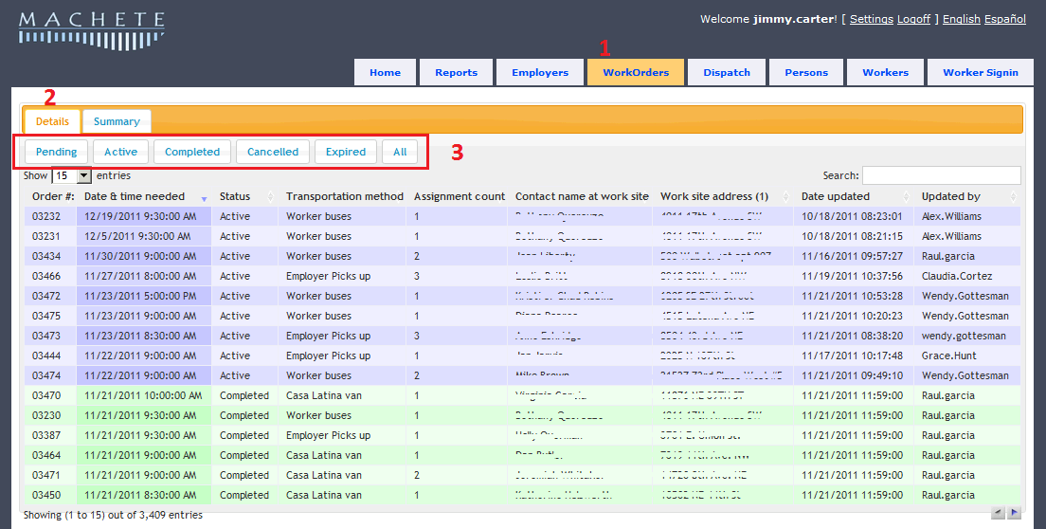

* Click on the WorkOrders Menu link (**Red #1**)
* Check on the Details Tab (**Red #2**)
* Filter work orders by their status using the filter buttons (**Red #3)**

Work Order Status Color meanings:

* + Grey work orders are pending
  + Blue work orders are active
  + Green work orders are assigned a worker and completed
  + Yellow work orders are assigned a worker and completed, but not associated with a worker signin record. (multiple dispatches in one day)
  + Orange work orders are completed, but missing a worker
  + Red work orders are cancelled

## Review Work Orders by Color

The image below is of the Work Order Detail stab with the Show Entries drop-down set to 100 entries. It shows many green completed orders, which is the goal for most orders.

The block of Blue orders means that one day, someone probably forgot to assign workers to work orders in Machete, and needs to assign them and close the orders. Orders need to be completed so that there is a record of who worked for the Employer. Also, only completed orders show up in some reports.

Grey orders mean the order is still pending. If the order is grey and in the past, it should be cancelled.

The Orange orders means that the order was marked as completed without a worker being assigned. This is an incomplete order. There will be no record of who worked for the Employer, survery data will not be meaningful, and some reports will be less accurate.

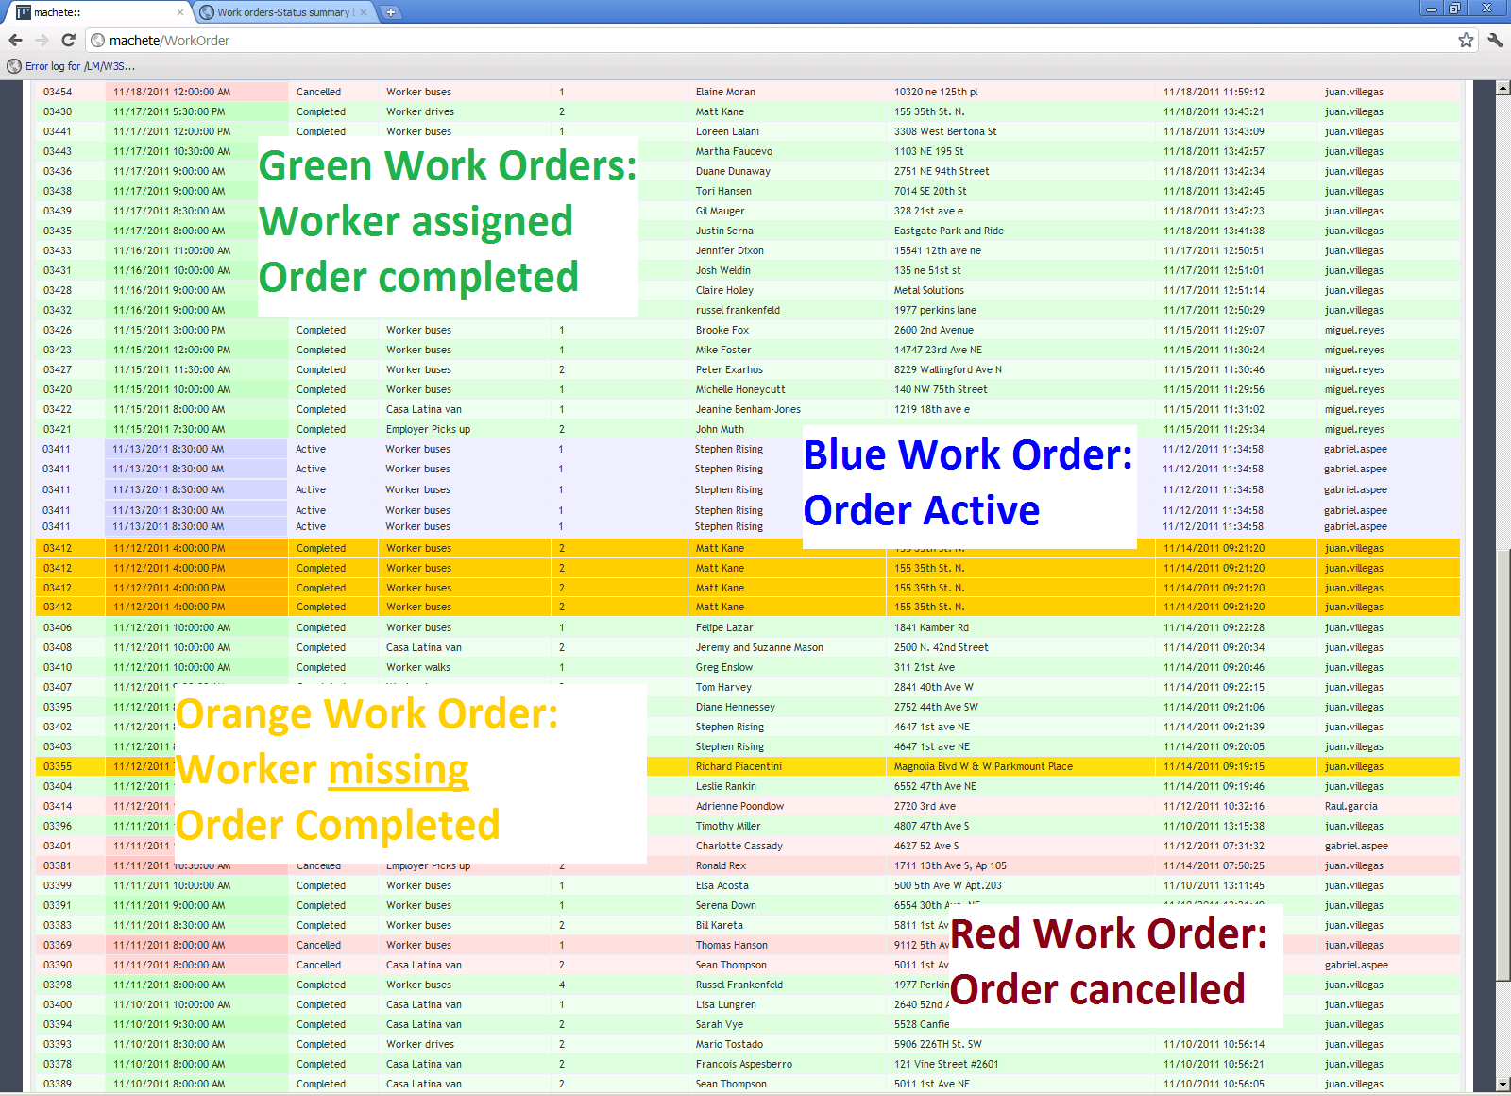

### Management Questions



#### Can the worker for the orange work order be found? If so, update Machete

#### Is the blue or grey order in the past? Do we have a paper record? Can we update Machete?

# Weekly operations tasks

Aside from the Work Order Summary and Details tab, all reports come from the Microsoft Report Server (SSRS). The Machete Reports page links to the reports developed for Machete; additionally, anyone can create their own reports using the server, but they will not be visible from Machete.

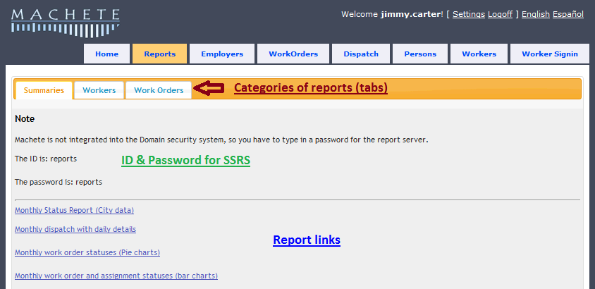

## Review Monthly Work Order Statuses (pie charts)

**(**[**http://machete/reports**](http://machete/reports) **-> Summaries Tab)**

The Machete Reports page is a simple portal to the reports available from the Report Server (SSRS).

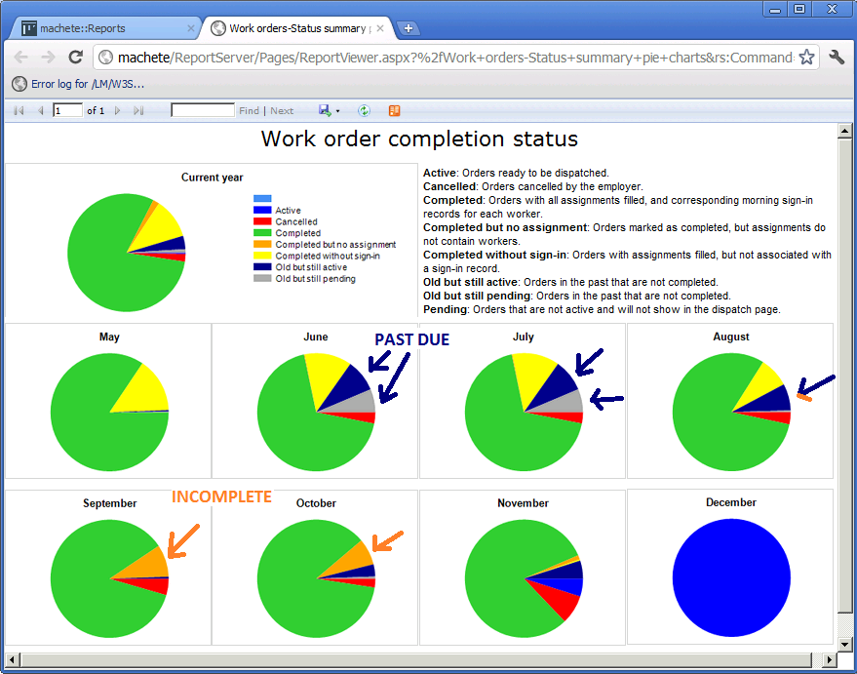

* The goal is to minimize or remove all the dark blue, grey, and orange orders.
* Some yellow and red are inevitable.

### Management Questions



#### Are the percentages of incomplete work orders shrinking?

* + - Orange work orders are completed, but missing a worker
      * Without a worker assigned, reporting will be less accurate
      * Without a worker assigned, there is no searchable record of who was dispatched

#### Are there work orders in the past that are not completed or cancelled?

* + - Blue work orders are active. Their date is either the current date or a future date
    - Dark blue are active but in the past; they should be completed or cancelled
    - Dark grey are pending but in the past; they should be completed or cancelled

## Review Incomplete Work Orders (List)

**(**[**http://machete/reports**](http://machete/reports) **-> Work Orders Tab)**

The Work Order page and the Details & Summary Tabs make is easy to see the status of recent work orders. However, work orders can quickly disappear as new orders are added. To find incomplete work orders that farther in the past, use the Incomplete Work Orders report.

The rows of the Incomplete Work Orders report the total number (Red #1) of work orders that are incomplete or past due.

* The second column shows how many of the incomplete do have workers assigned to the work order

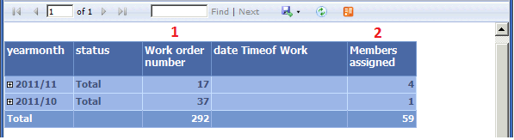

* The difference between the work order number and the members assigned is the number of work orders that are missing worker assignments
* The goal is to reduce the numbers in both columns by filling all the work orders with workers, then completing the work orders

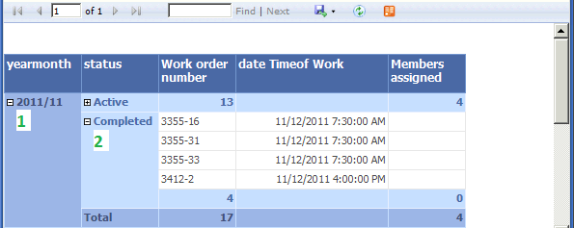

The Incomplete Work Orders report will allow the user to expand monthly totals to show sub-totals by the statuses of the incomplete orders. In the example above, for November 2011 (**Green #1**), there are 17 incomplete work orders. Of those orders, 13 have their status set to Active and 4 are marked as Completed.

The user can further expand the Status record and show the individual work orders and their Order Number, so they can be quickly accessed in Machete. The Date & Time of the work order is also visible.

The Work Order number has two parts [#####-##]:

* the Work Order Number
  + hyphon [-]
* the Assignment Number

The Assignment number reflects which assignment in the work order is missing information

### Manager Questions



#### Can we find which worker was assigned for a given incomplete work order?

#### Are the total numbers of incomplete work orders shrinking over time?

#### What can be done so that there are no incomplete orders in the coming month?

## Review Workers-Signins Past Membership Expiration

**(**[**http://machete/reports**](http://machete/reports) **-> Workers Tab)**

Machete is designed to track a membership date for each worker to track whether workers meet the organization’s objectives for membership. A text message that a worker is expired flashes when the worker registers every morning. However, if too many workers are expired, the message will be ignored.

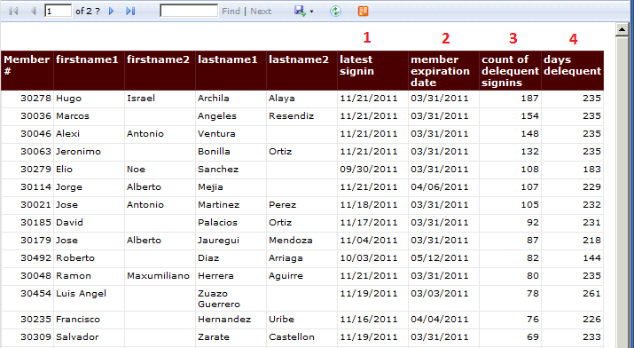

* Review the Signins Past Membership Expiration list to identify which workers need to renew their membership
* The report shows
  + the latest date of signin by the worker (**Red #1**)
  + the date of membership expiration (**Red #2**)
  + the number of signins since expiration (**Red #3**)
  + the number of days since expiration and the latest signin (**Red #4**)

### Manager Questions

#### Are the worker records current?

#### Do they reflect all renewed memberships?